**Code sniffer for Netbeans**

Please check the following steps to set up “code sniffer” in the Netbeans IDE.

1. Download the plugins from below URL:

<https://sourceforge.net/projects/phpmdnb/>

1. Go to the Netbean’s Tool > Plugins > Available plugin menu tab.
2. Search plugin by phpCS-MD, select it and proceed to install.

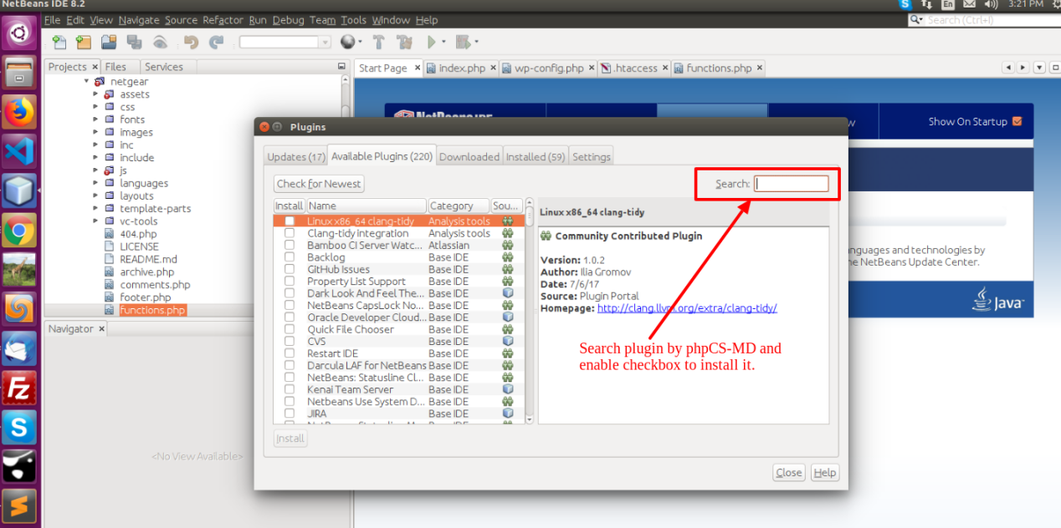

1. Once installed open the terminal and check the status through below command.

phpcs -i

1. If it is not installed, you can enter below command in the terminal.

sudo apt install php-codesniffer

1. once installed, restart the Netbeans and go to the

tools > options > PHP > Code Sniffer

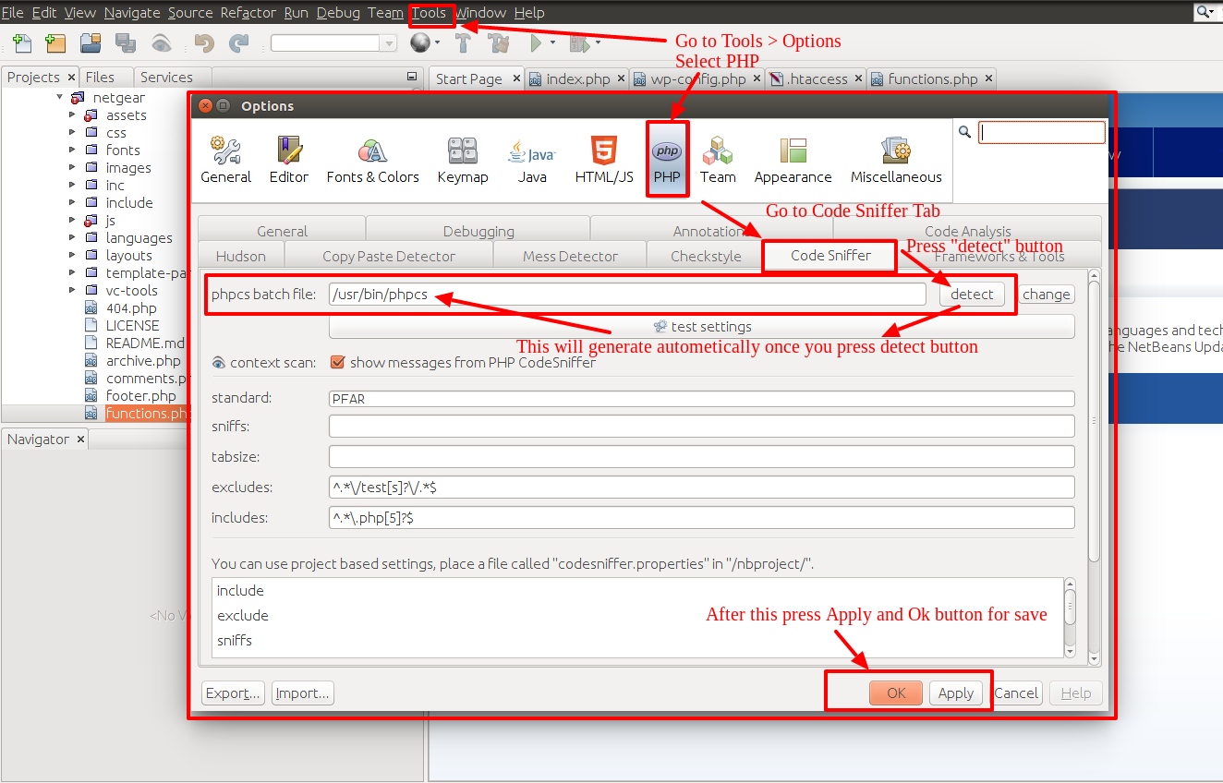

1. Click on the "detect" button following by "test settings".
2. Now your code sniffer tool has been installed. To check how it works you will see the “blue eye icon” in the address bar.

